HISTORICAL & ARCHITECTURAL REVIEW BOARD

APPLICATION #1: The applicant proposes to renovate the façade of the building including
trim, millwork, new windows and signage at 534 Main St. (McCarthy’s
Red Stag Pub and Whiskey Bar)

OWNER: Neville Gardner
534 Main St., Bethlehem, PA 18018
__________________________________________________________________

The Board upon motion by Connie Glagola and seconded by Gen Marcon adopted the proposal that City Council issue a Certificate of Appropriateness for the following:

- Renovate the façade of the building along Walnut Street.

- The colors will match the existing colors on the Main Street façade.

3. Windows to be aluminum frames in a green color with clear glass.

4. Signage to be gold letters, pin mounted on a black background.

5. The motion was unanimously approved.

__________________________________________________________________________

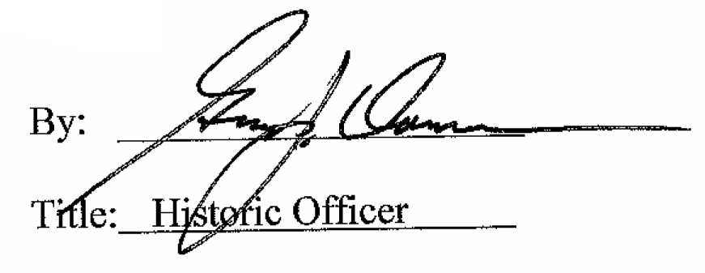

Date of Meeting: April 1, 2015
RESOLUTION NO.__________

RE: CERTIFICATE OF APPROPRIATENESS UNDER THE
PROVISIONS OF THE ACT OF THE PENNSYLVANIA
LEGISLATURE 1961, JUNE 13, P.L. 282 (53
SECTION 8004) AND BETHLEHEM ORDINANCE NO.
3952 AS AMENDED.

WHEREAS, it is proposed to renovate the Walnut Street façade of the building at 534 Main St. (McCarthy’s Red Stag Pub & Whiskey Bar)

NOW, THEREFORE, BE IT RESOLVED by the Council of the City of Bethlehem that a Certificate of Appropriateness is hereby granted for the proposal.

Sponsored by: (s)

(s)

ADOPTED BY COUNCIL THIS DAY OF

(s)
President of Council

ATTEST:

(s)
City Clerk

